N-W.F.P University of Engineering & Technology Peshawar Pakistan 25000. ^{Final} ^{Term} Examination, 2nd Semester Spring 2006
CE: 104 MECHANICS OF SOLIDS-1
Duration: 02hrs & 15min
Note: Max: Marks = 50
- Text Books, Reference Books, and Class Notes are not Allowed.
- Any Programmable calculator is not Allowed.
- All Questions are compulsory and carry equal Marks.
Q-l:
Sketch Shear Force and Bending Moment Diagram for the given Beam by Formulating Shear Force and Bending Moment for each section. Also Show values for Shear Force and Bending Moment at each Load change points and applied Loads.
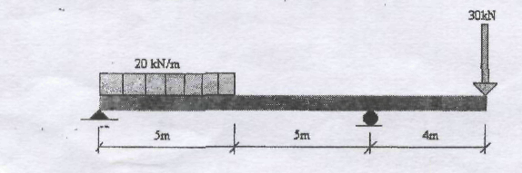
Q-2:
A simply supported Beam, 2-in wide by 4-m high and 12-ft Long, is subjected to UDL of intensity 100 Ib/ft² and a concentrated Load of 2000 Ib at a point 3-ft from Left support. Determine,
- Maximum Flexure Stress.
- Stress in a Fiber Located 0.5-in from the top of the Beam-Section at Mid-Span.
Q-3:
a) For the Beam Shown below, Calculate
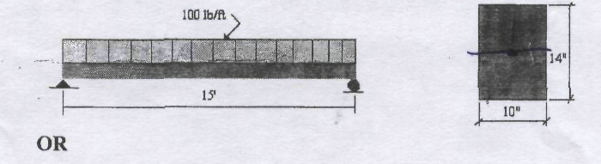
b) Calculate Flexure Stress at Extreme Top Fibers and Extreme bottom Fibers, and also sketch their variation along the depth. Take Moment equal to 100 ft-lb.
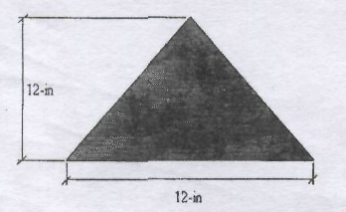
Q-4:

Find out Deflection and Slope at Mid-Span of UDL by Double Integration Method.
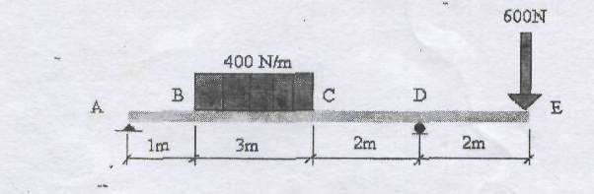
Q-5:
Calculate Deflection and Slope at B for the Beam given below by any of the Methods given below,
- Area-Moment Method.
- Conjugate Beam Method.
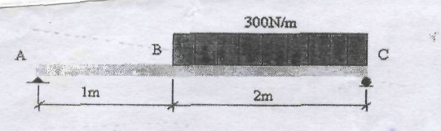

Maximum Horizontal Shearing Stress.

